Knowledge Document:
Pegasys – View Errors on a Charge
Summary:
This document explains how to resolve credit card errors within the reconciliation notebook in Pegasys.
Problem:
The user needs assistance in resolving a transaction in “Error” status.
Resolution:
Step 1 - In Pegasys, go to Transactions>Credit Cards>Reconciliation.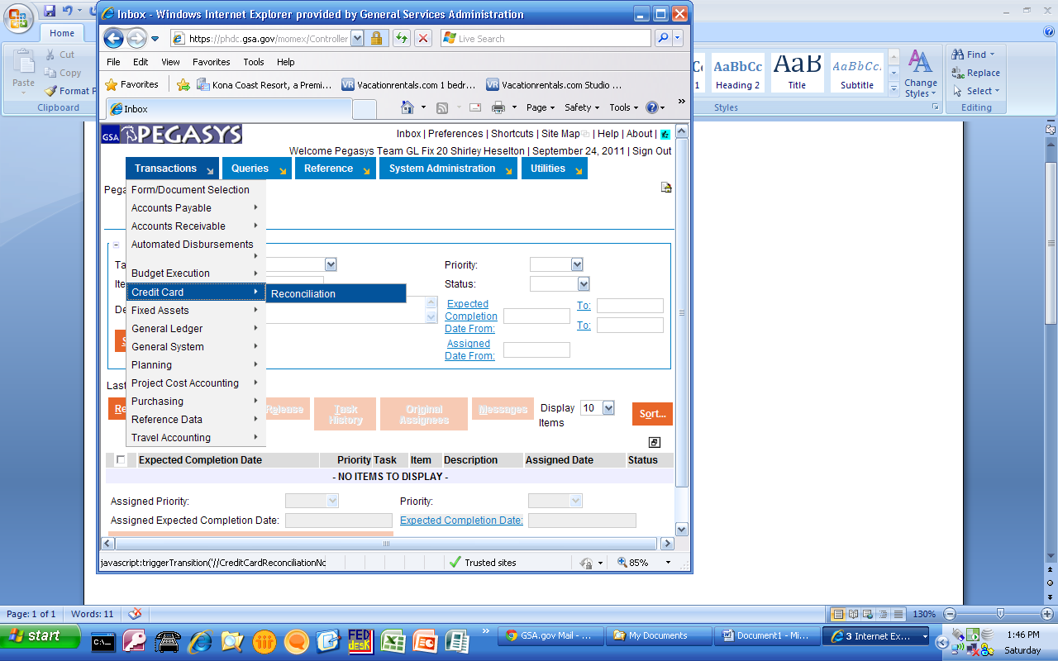

Step 2 – Select the appropriate alias; select “Error” in the “Status” field ; click “Search.”
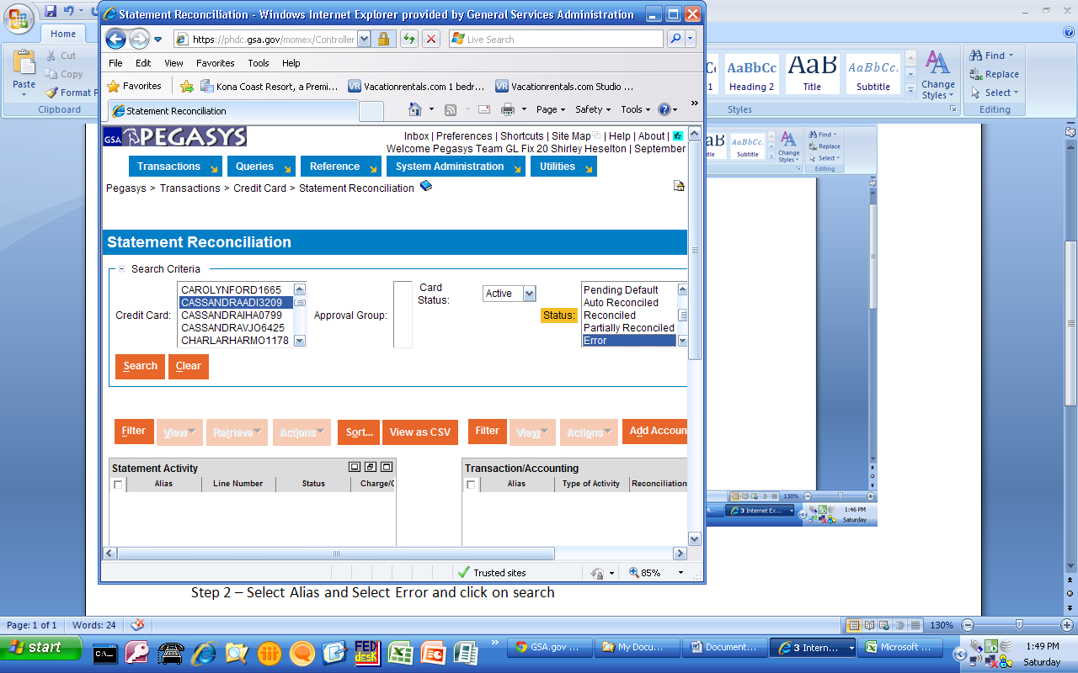

Step 3 – Select the error that you wish to look at.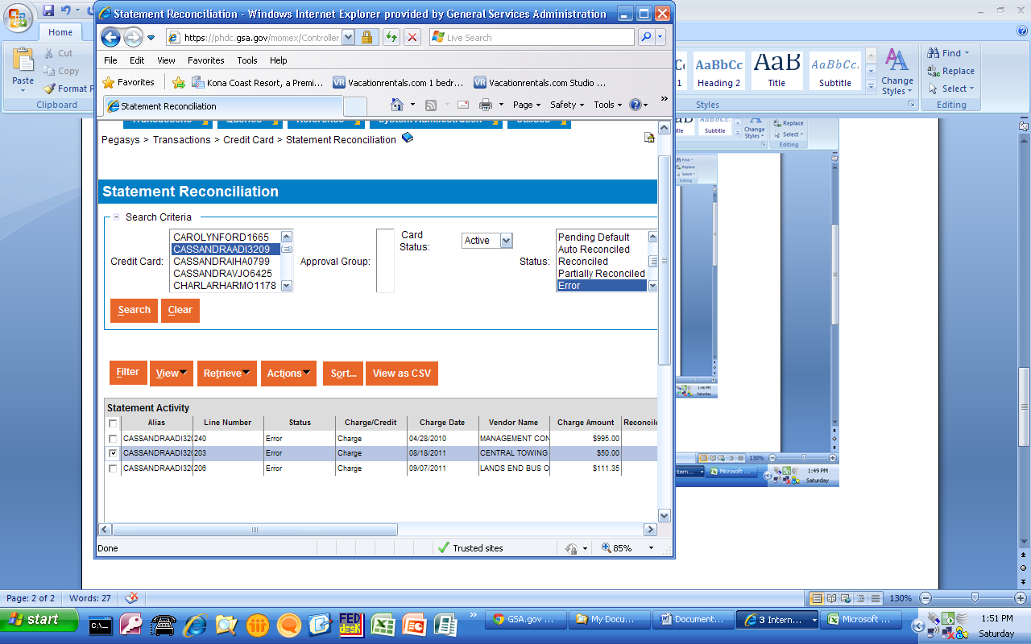
Step 4 – Click on View>Payments.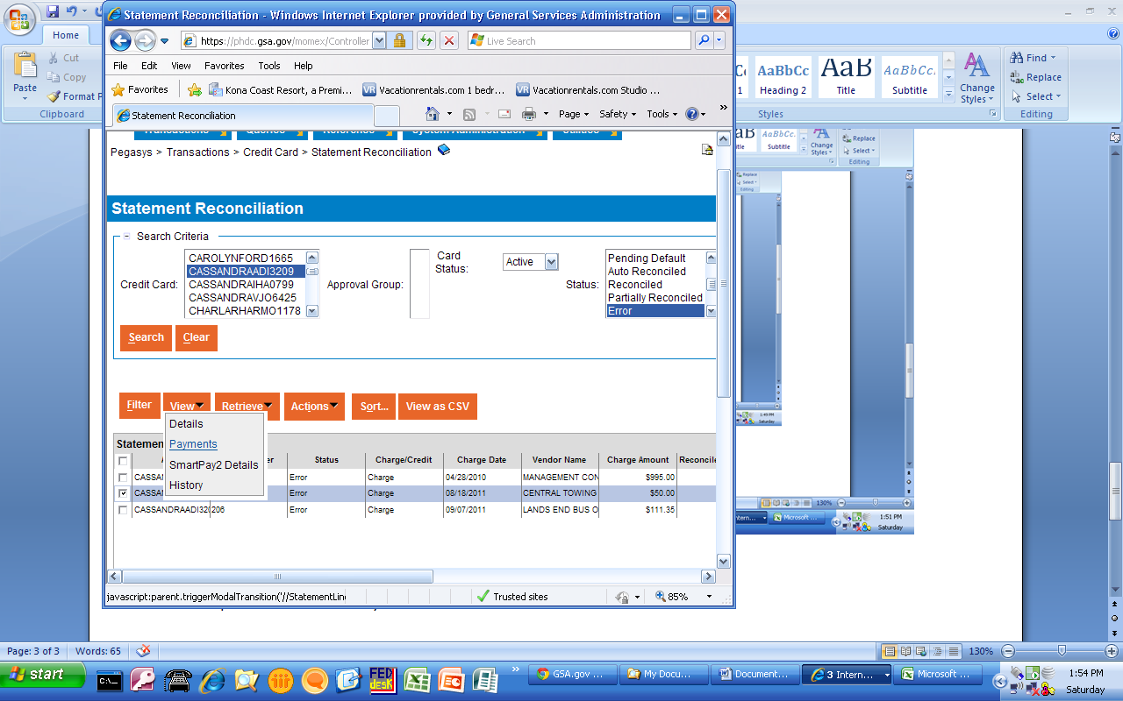
Step 5 – Select the earliest CP that was rejected and click on “View Document”.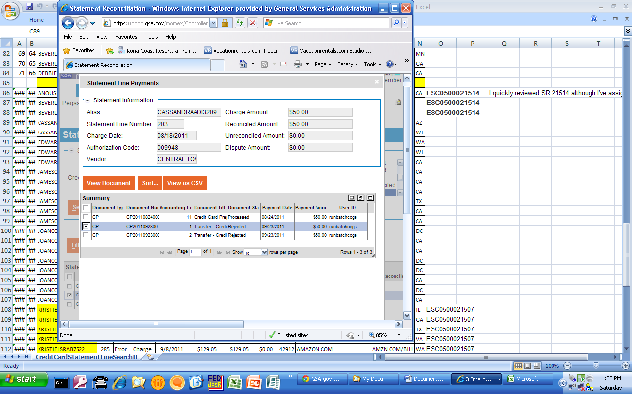
Step 6 – The document will have the error message(s) at the top and will contain the header accounting line number.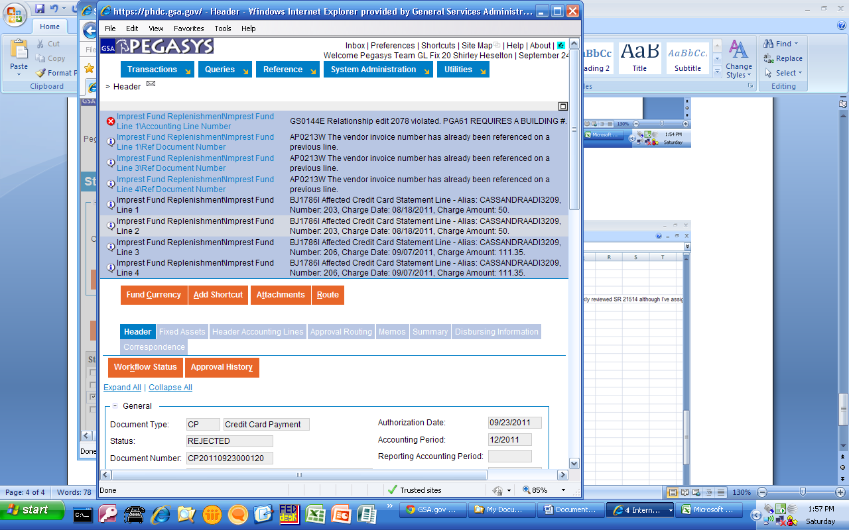
Step 7 – Click on the “Header Accounting Lines” tab and find the line number causing the error. It will provide the CL or CT number causing the problem without actually opening the header accounting line. Scroll right to find the CL or CT number causing the error.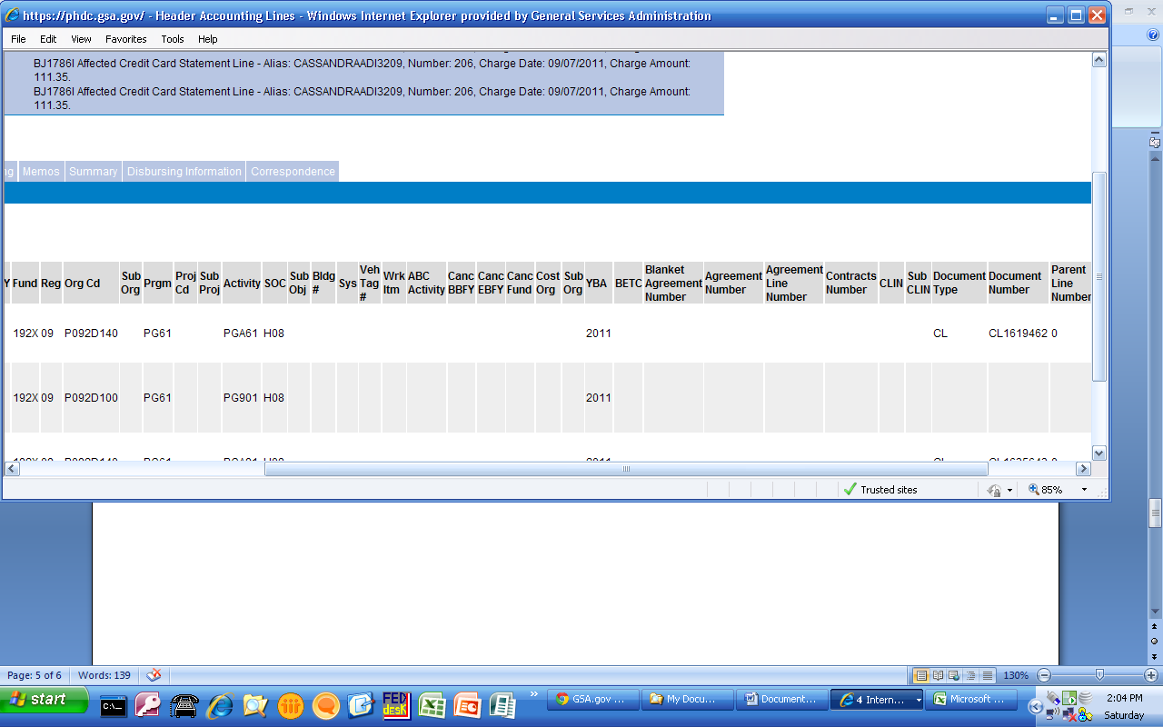Step 8 – Close out of the CP document and retrieve reconciliation activity for the charge by clicking the check box next to the charge in the “Statement Activity” window and then clicking the “Retrieve” button in the “Reconciliation Activity” window.
In this case the CL or CT document that the charge is reconciled to is also the one that is causing the error, although this is not always the case. Unreconcile the charge from the document.
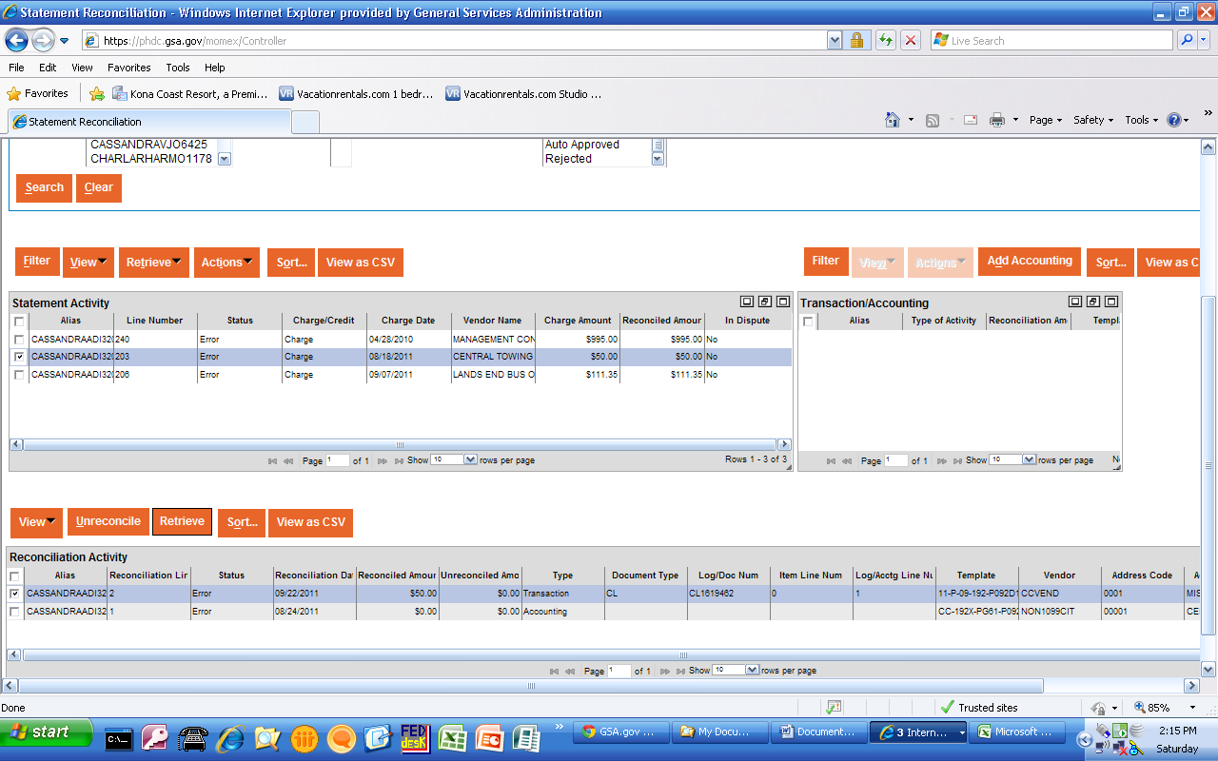
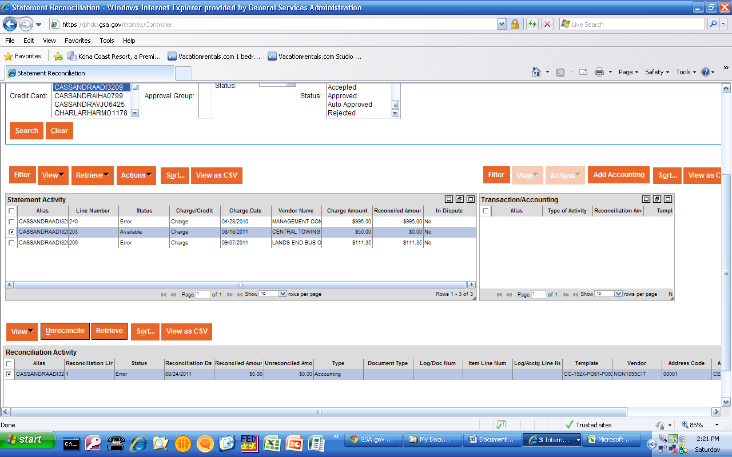
Step 9 – Go to Transactions>Form/Document Selection and search for the CL or CT document.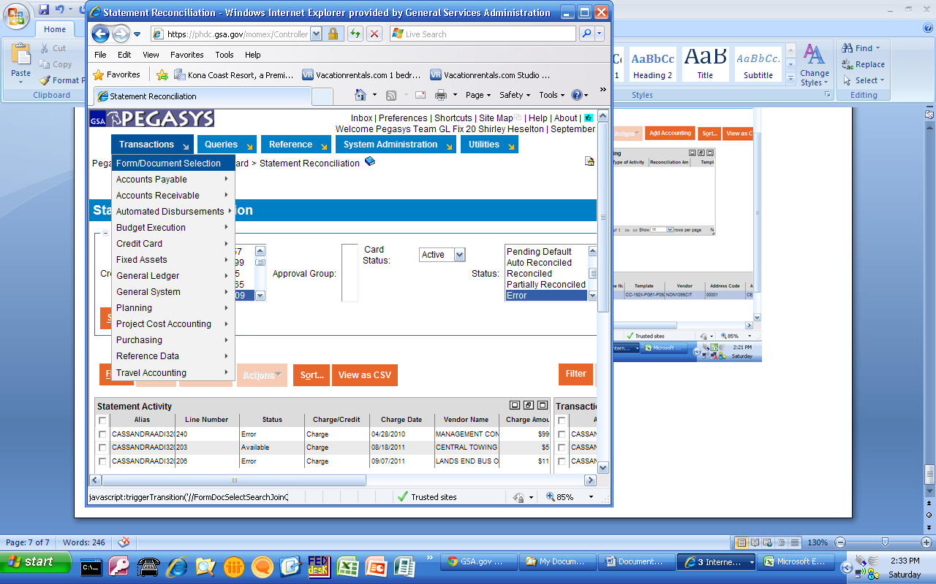
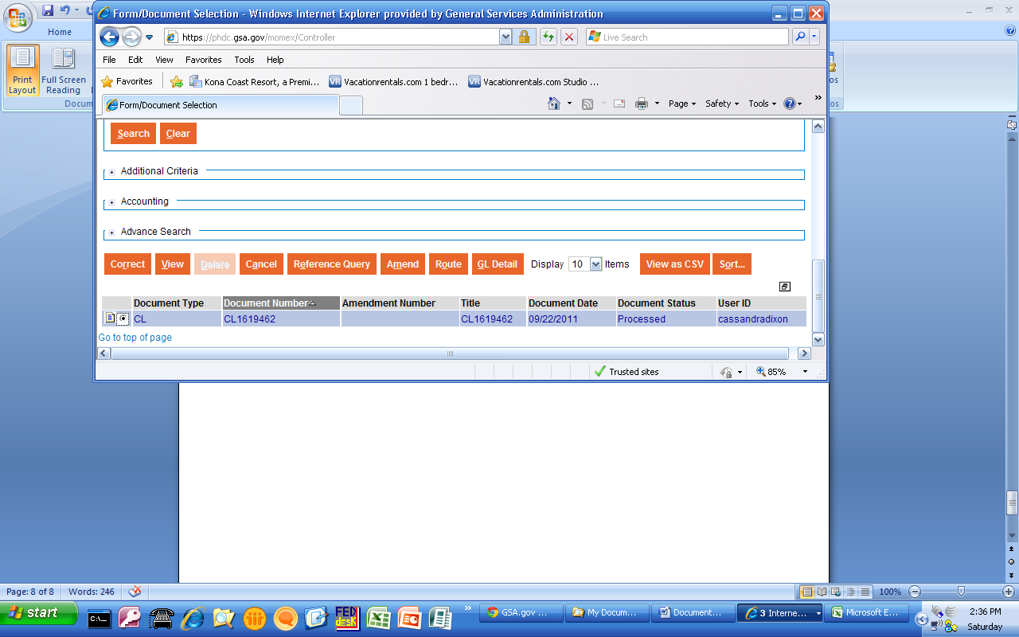
Step 10 – Open the document in “Correct” mode. After clicking “Verify” you should receive the same error as seen on the CP document. Correct the CL or CT and re-verify, submit and re-approve.
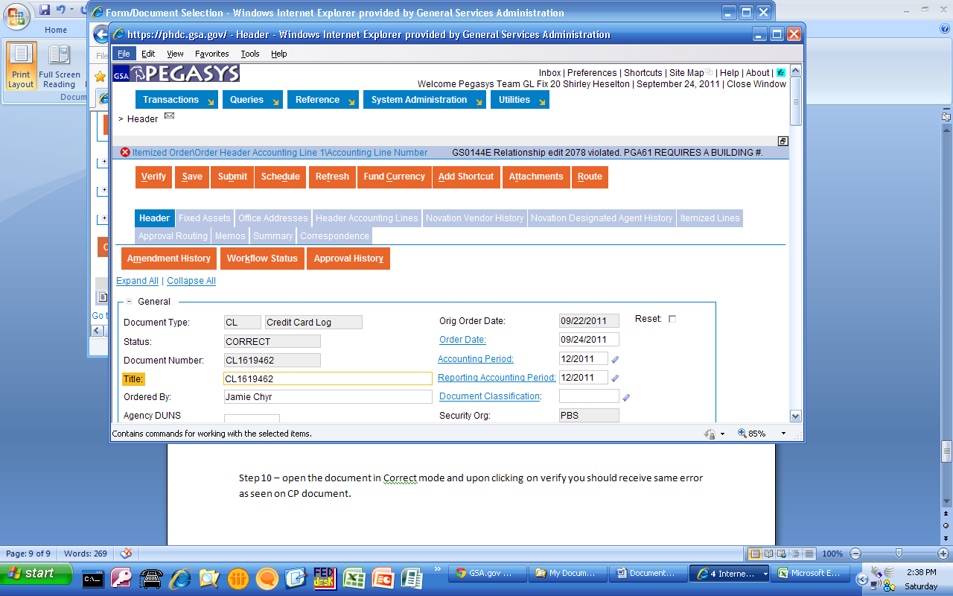

Step 11 – Re-reconcile the charge to the CL or CT that has been corrected.
A charge can also be in “Error” status despite the fact that there is nothing wrong with the credit card log the charge has been reconciled to. If this is the case, it may be useful to un-reconcile the charge, wait for the overnight batch process to run, and then reconcile the charge again.

